Git Hands-on 3: Branching & Merging
Objective
- Create and work on a new branch.
- Make changes and commit them in the branch.
- Merge changes into master/main.
- View differences using CLI (and optionally P4Merge).
- Delete the branch after merge.

1. Prerequisites
- Git installed and configured.
- Local repository at C:\Users\choll\GitDemo.
- P4Merge installed (optional for visual diff).

2. Steps
1. Navigate to the Repository Root
cd /c/Users/choll/GitDemo
pwd
ls -a
git branch --show-current
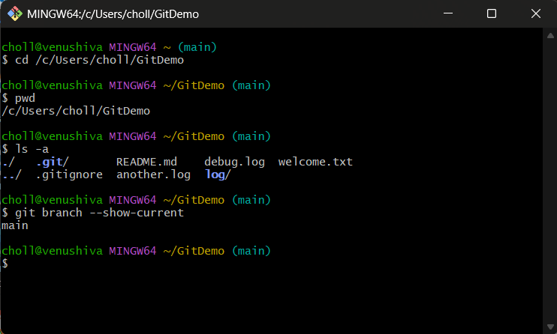
2. Create a New Branch
git branch GitNewBranch
git branch -a
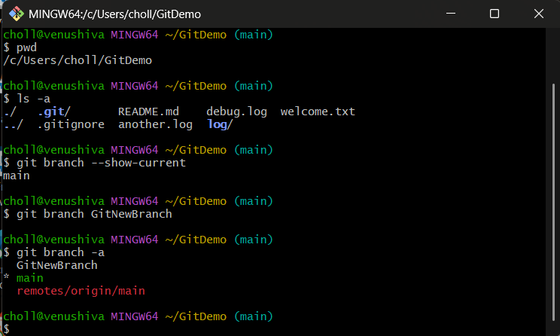

3. Switch to the New Branch
git checkout GitNewBranch
git branch --show-current
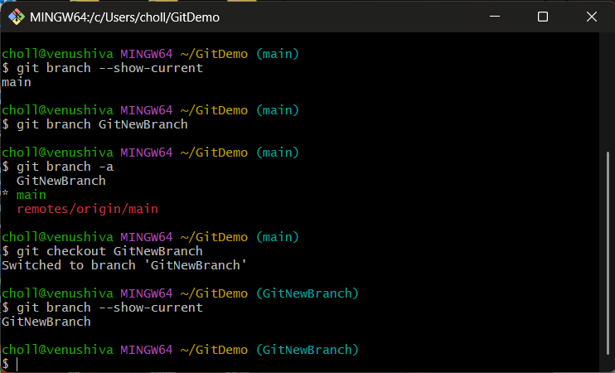

4. Add a File in the New Branch
echo "This is content in GitNewBranch" > branchfile.txt
git status
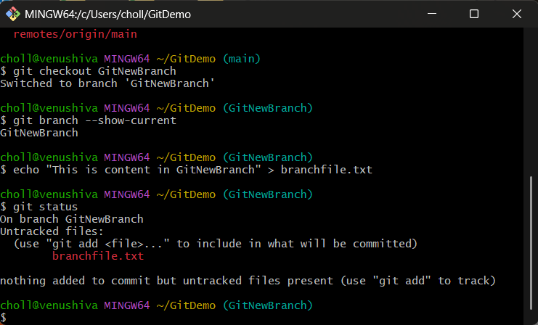
5. Stage and Commit the File
git add branchfile.txt
git commit -m "Add branchfile.txt in GitNewBranch"
git status
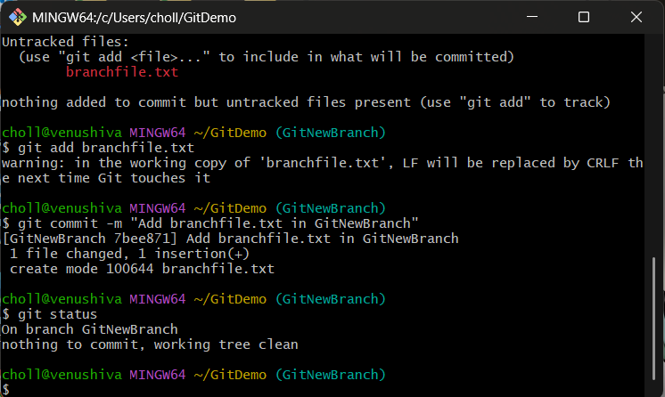

6. Switch Back to Master/Main
git checkout master # or: git checkout main
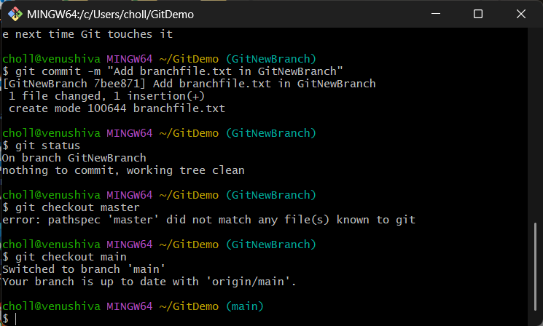

7. Show Differences Between Branches (CLI)
git diff main GitNewBranch
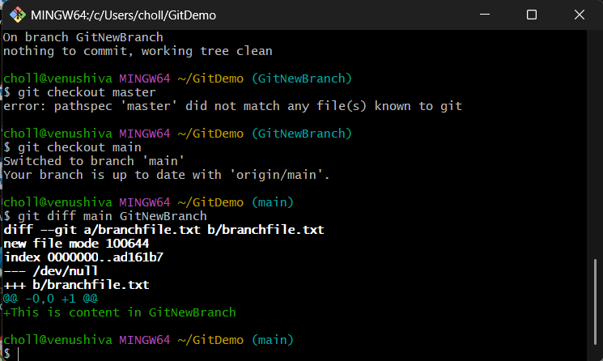

8. Merge the Branch into Master/Main
git merge GitNewBranch
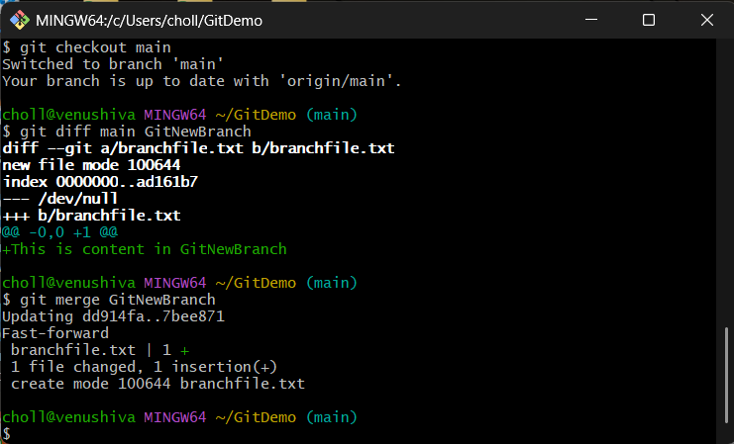

9. View Merge History Graph
git log --oneline --graph --decorate
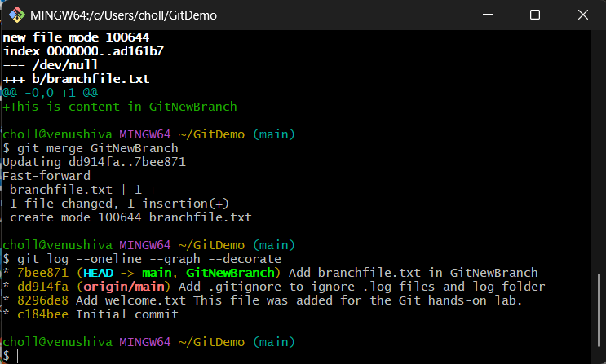

10. Delete the Branch
git branch -d GitNewBranch
git branch -a
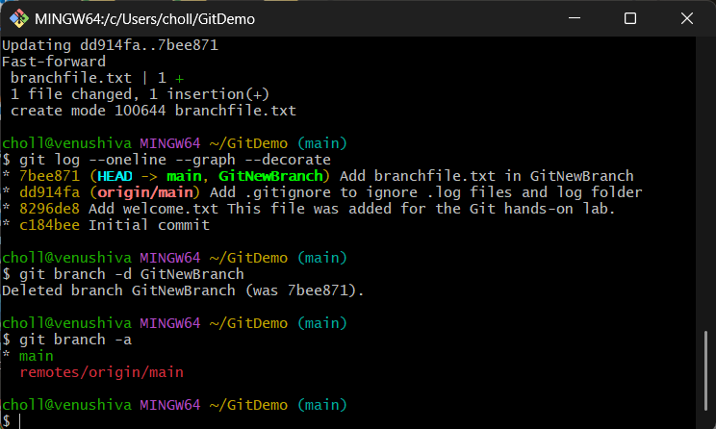

11. Final Status
git status
